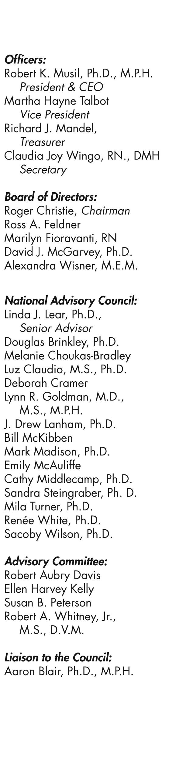
____________________________________________________________________________________________

FOR IMMEDIATE RELEASE
September 14, 2023
Contact: Claudia Steiner, (862) 368-7811, claudia@rachelcarsoncouncil.org
Lawmakers Urge Biden to Phase Out Fossil Fuels in Advance of Climate Ambition Summit
Washington, D.C. — U.S. Sens. Jeff Merkley (D-Ore.) and Ed Markey (D-Mass.) and U.S. Reps. Rashida Tlaib (D-Mich.), Barbara Lee (D-Calif.), and Schakowsky (D-IL) joined climate advocates urging President Biden to commit to stop approving fossil fuel projects, phase out fossil fuel production on federal lands and waters, and declare a climate emergency before the United Nations’ Climate Ambition Summit on the 20th. The rally took place ahead of the March to End Fossil Fuels, which will be held in New York City on Sunday.
“The month of July was the hottest month ever recorded. With record droughts, flash floods, 100-degree ocean waters, and fires burning out of control—our planet Earth is quite literally crying out for help,” said Senator Merkley. “The President must declare a climate emergency and stop approving new fossil fuel projects. We must invest in, and lead, a real and just transition to clean energy. The solution is not complicated, but we must act now!”
Fossil fuels are the primary driver of the climate emergency. They are responsible for 1 in 5 deaths worldwide and the increasingly more frequent and severe climate disasters that have affected so many of us this year. The wildfires, smoke, flooding, and heat waves of 2023 are only the beginning of the climate emergency if world leaders allow global warming to exceed 1.5 degrees Celsius.
“Growing up in El Paso, Texas, under the shadow of the Asarco copper smelter, I saw firsthand how fossil fuels harm communities. Unfortunately, my experience was not unique,” said Representative Barbara Lee. “From deadly fires in Maui to record-breaking heat in California, the climate crisis is changing our world as we know it—and we know this is only the beginning of the climate emergency unless the United States begins phasing out fossil fuels."
“The climate crisis isn’t just on our doorstep, it’s in our homes,” said Senator Markey. “We have no time to waste in stopping Big Oil from polluting the air we breathe and the water we drink – all while lining their own pockets by price-gouging hard-working Americans. I call on President Biden to not only phase out dirty fossil fuels but also declare a climate emergency so that generations to come have a livable, brighter future.”
It is still possible to limit warming to 1.5°C. United Nations Secretary-General Guterres is hosting the Climate Ambition Summit to solicit credible commitments from world leaders to stop fossil fuel expansion and begin fossil fuel phaseout in line with his 1.5°C- aligned Acceleration Agenda.
To maintain a likely chance of limiting warming to 1.5°C, the U.S. should end ALL oil and gas production by the early 2030s. The United States is currently the world’s top oil and gas producer, and is responsible for over ⅓ of the world’s planned oil and gas expansion by 2050. President Biden must reverse course, and begin phasing out fossil fuels now.
Keanu Arpels-Josiah an 18 year old activist with Fridays For Future NYC said “The U.S. is planet wrecker in chief—responsible for the largest amount of fossil fuel emissions, so the onus for action is on the US and President Biden. On Sunday at the March To End Fossil Fuels in New York City, we will make it clear, we voted for a climate president, not for fossil fuel expansion.”

Millions of people around the world will take to the streets in the coming days to ask world leaders to end fossil fuels. Global days of action start tomorrow, September 15th, culminating in the March to End Fossil Fuels, in New York City on September 17th.
"As a community member of Utqiagvik in Alaska, we vehemently challenge the false narrative that the entire North Slope welcomes the relentless expansion of oil operations, especially near Teshekpak Lake,” said Sara Thomas, SILA advisory board member and Environmental Justice Organizer for Alaska Community Action on Toxics. “Recent public meetings on the proposed Willow project in Utqiagvik saw overwhelming opposition. In fact, I’ve never seen a more packed public meeting. Fossil fuel corporations, despite their immense wealth, have failed to address pressing community issues like housing shortages, youth recreation, food security, and mental health support services. This begs the question: What's different this time? It's clear this is about profit, power, and ignoring the climate crisis. Dismissing opposition as solely external ignores the multitude of local and Indigenous voices unwavering in their commitment to preserving our land, wildlife, and cultural heritage. Together, at the March to End Fossil Fuels on Sunday, let's unite to end fossil fuels and forge a sustainable future for our communities in Alaska, and the rest of the world."

###
The Rachel Carson Council is the national environmental organization envisioned by Rachel Carson and founded in 1965. The RCC educates, organizes, and advocates for climate justice, environmental health, and the promotion of Carson's environmental ethic of empathy for all living creatures.

